Description:

We use the CRUST-1.0 model (ignoring the ice layer, water layer) at the source location, spliced with the AK135 model, as the one-dimensional velocity structure Earth model for calculating the Green's function library. The core Fortran code used for calculating the Green's function library is compiled into an exe executable file, which can run on x64 architecture Windows devices.

1. Using the "crust1model" function to generate the CRUST1.0 structure files at the epicenter.

The input for the function is (Lat, Lon, sentiment), where you input the longitude and latitude of the epicenter, and whether to consider the velocity structure of the sedimentary layer (1 for considering, 0 for ignoring). This will generate two CRUST1.0 structure files at the epicenter, with the filenames ('Crust1.0_Lon%.1f_Lat%.1f.txt', Longitude, Latitude) and 'earth.mat'. Copy the 'earth.mat' file into the working directory.

1. Preparation of the near-field strong earthquake Green's function library

Copy Green_sm into a new folder and rename it to a suitable name. Edit grn.inp in the new folder (see point 4), and then run dbgrn.exe to calculate the Green's function library. The calculation usually takes a few minutes.

1. Preparation of the teleseismic Green's function library

Copy Green_tele into a new folder and rename it to a suitable name. Edit grn.inp in the new folder (see point 4), and then run dbgrn.exe to calculate the Green's function library. The calculation generally takes several tens of minutes.

1. Modifications to grn.inp

Modifications can be made by reading the instructions within the file. Here are the key areas that need to be modified:

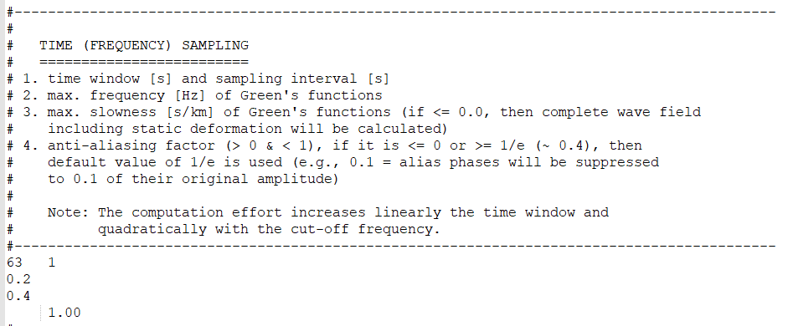

The first line: The duration of the Green's function time window and the sampling interval. The duration must be 2n sampling interval, and it should cover the time from the earthquake initiation to the arrival of seismic waves at the station. For strong motion Green's functions, a duration of 512 sampling interval is recommended, while for teleseismic Green's functions, a duration of 2048 (or 4096) sampling interval is recommended.

The second line: The maximum frequency of the Green's function, set here at 0.2Hz. If the high-frequency component of waveform filtering in the inversion is greater than 0.2Hz, then this value needs to be adjusted to a higher frequency.

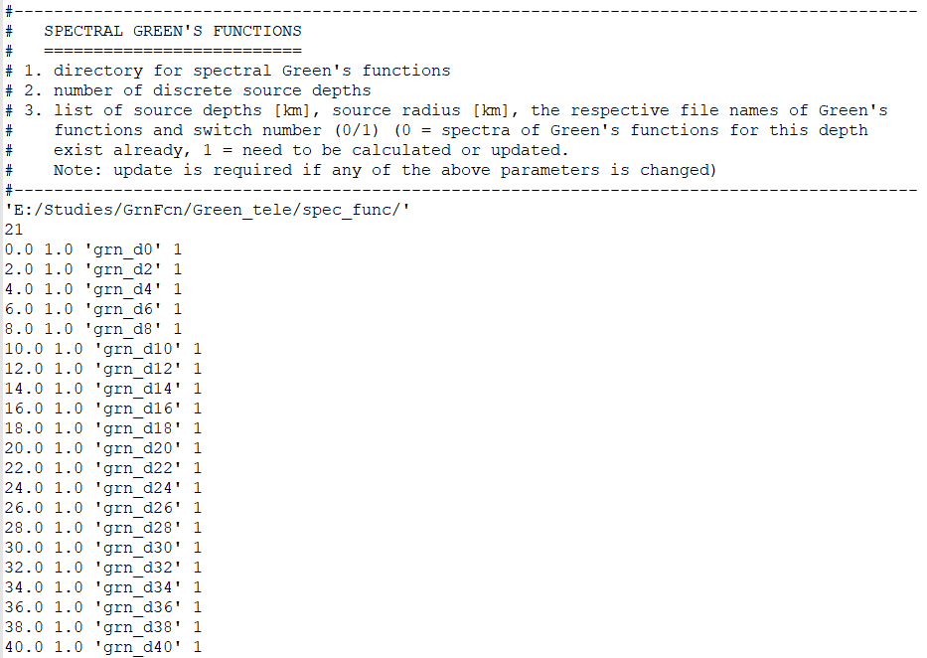

The first line: The path to the Green's function library. Please change the part in front of '*/spec_func/' to the path where this Green's function library is located.

The second line: The number of Green's function depths calculated, corresponding to the third line and below.

The third line and below: The depths of the Green's functions being calculated. Here, Green's functions at 2km intervals within 0-40 km are provided. If you need to calculate Green's functions at greater depths or with smaller depth intervals, please modify accordingly and adjust the number on the second line.

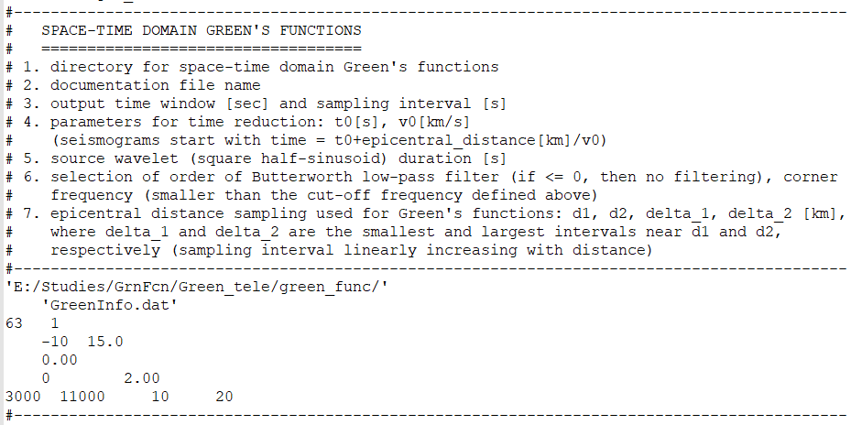

The first line: The path to the Green's function library. Please change the part in front of '*/green_func/' to the actual path where this Green's function library is located.

The third line: The duration of the Green's function time window and the sampling interval. The duration must be 2n sampling interval, and it should cover the time from the earthquake's initiation to the arrival of seismic waves at the station. For strong motion Green's functions, a duration of 512 sampling interval is recommended, while for teleseismic Green's functions, a duration of 2048 sampling interval is recommended.

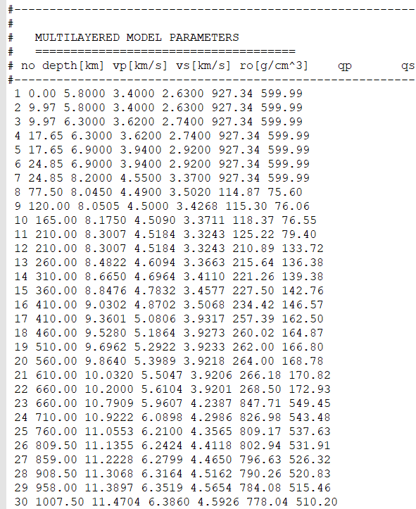

Subsurface layer model parameters. Please replace the subsurface layer model parameters here with the contents from the ('Crust1.0_Lon%.1f_Lat%.1f.txt', Longitude, Latitude) file generated in part 1.